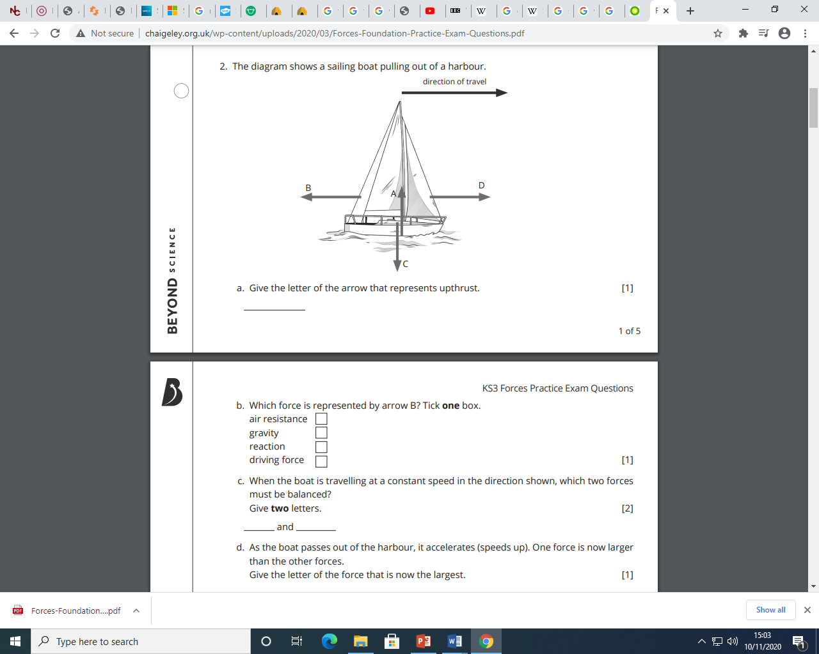



3. A spring can be stretched by hanging masses on it. Which of the following is true?

1. The larger the force, the greater the stretch
2. The smaller the force, the greater the stretch
3. The spring does not exert a force on the mass
4. Mass does not exert a force on the spring

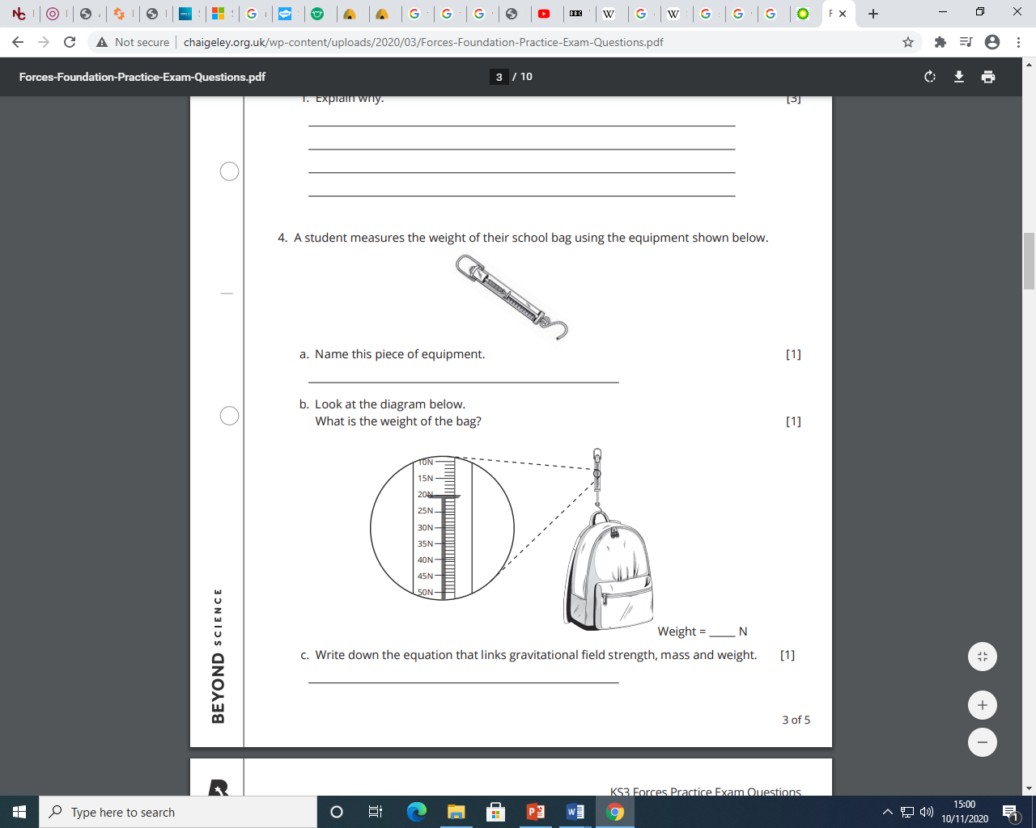

5. Which of the following is NOT a force?

1. Gravity
2. Mass
3. Pull
4. Weight

What are forces measured in?

What is weight measured in?

1. Joules
2. Kilograms
3. Newtons
4. Pascals